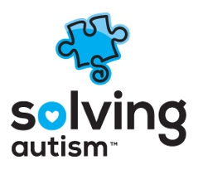

Sliding Scale/Pro Bono Services for Clients Not Using Insurance

For clients that do not have the assistance of private insurance to assist with the cost associated with ABA therapy, Solving Autism offers a sliding scale payment option. This sliding scale is based on income and number of dependents.
We also offer some services at Pro Bono, whenever possible, for families who are unable to cover the prices of ABA therapy for their child; and who do not have private insurance or Medicaid services to assist with covering the costs of ABA therapy.
If you would like to get information regarding receiving sliding scaled services or pro bono services, please call or email:
Phone: 540-818-8819
Fax: 803-845-4977
Hiring Manager/HR: Carrie@solvingautism.com

